Commodore PET Joystick Adapter Rev. 0
Module Description

Introduction
This is an adapter for connecting the widespread Commodore C64 or Atari Joysticks to the user port of the PET series computers.
There is no real standard for doing so, thus the most common pin assignments at the user port had to be determined. The main source was the website zimmers.net. The document https://www.zimmers.net/anonftp/pub/cbm/documents/projects/interfaces/pet_joystick.txt shows a pin assignment, that was used for most joystick games, that could be found on the website (https://www.zimmers.net/anonftp/pub/cbm/pet/games/english/joy/index.html). This pin assignment is also found at the original “Coyote Electronics“ joystick adapter“ and it is the one that is used for the „PET“ joystick emulation in the VICE PET emulator.
There is a further pin assignment for „left/right/fire“ games, that can also be found on the said website, which is not identical to the first pin assignment. The up/down directions are not defined for most of those games, except “leap frog fix.prg”. The found pin configuration was confirmed by „Stupid PET tricks“ adapter. There it is called “Space Invader +”, thus the name.
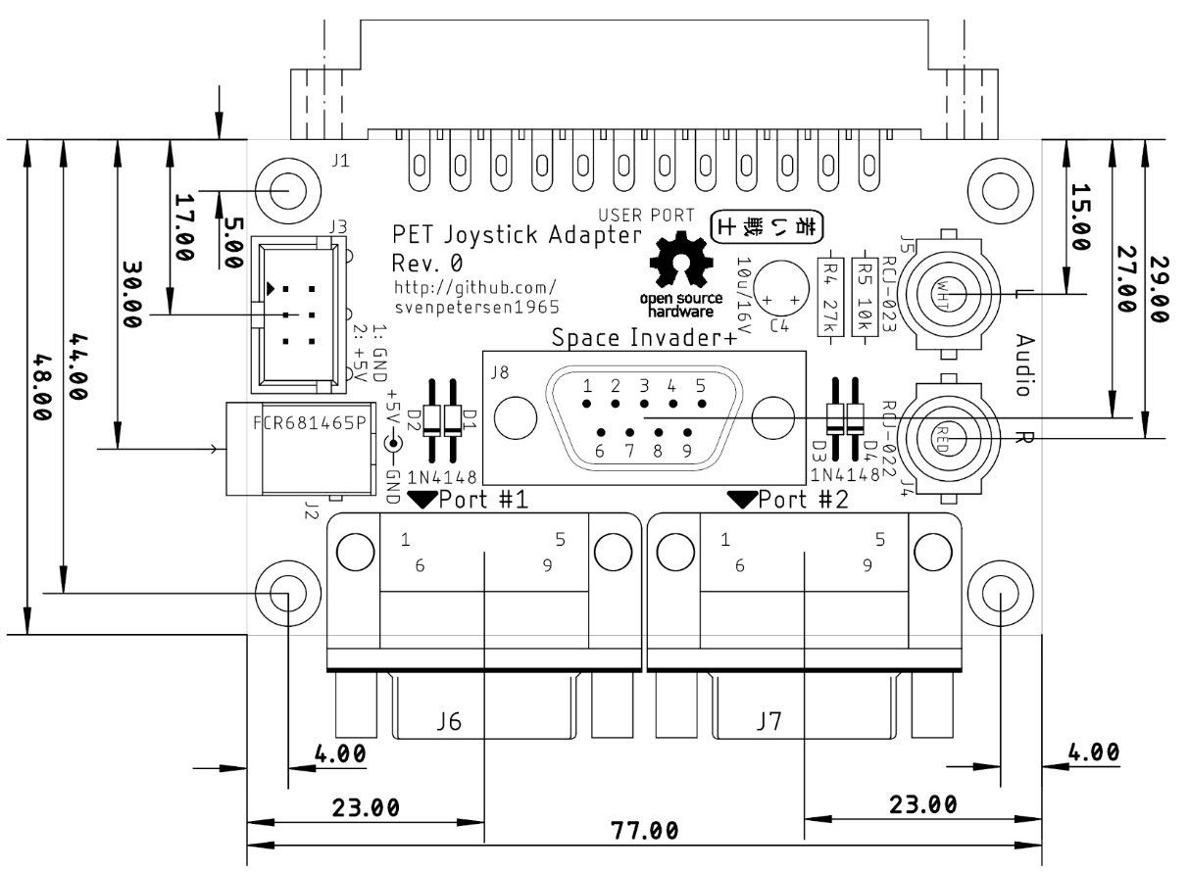Figure 1: Dimensions of the PCB

Pin Assignments

Coyote Electronics
Port | D-Sub Pin | Direction | User Port | Pin
1 | 1 | Up | PA0 | C
1 | 2 | Down | PA1 | D
1 | 3 | Left | PA2 | E
1 | 4 | Right | PA3 | F
1 | 6 | Fire | PA0 & PA1 (Diodes) | C & D
1 | 7 | +5V | Not available | -
1 | 8 | GND | GND | 1, 12, A, N
2 | 1 | Up | PA4 | H
2 | 2 | Down | PA5 | J
2 | 3 | Left | PA6 | K
2 | 4 | Right | PA7 | L
2 | 6 | Fire | PA4 & PA5 (Diodes) | H & J
2 | 7 | +5V | Not available | -
2 | 8 | GND | GND | 1, 12, A, N

Space Invader +
D-Sub Pin | Direction | User Port | Pin
1 | Up | PA2 | E
2 | Down | PA3 | F
3 | Left | PA0 | C
4 | Right | PA1 | D
6 | Fire | PA4 & PA5 (Diodes) | H & J
7 | +5V | Not available | -
8 | GND | GND | 1, 12, A, N

Further Features

Power Supply
The +5V supply voltage is usually not required, it only serves for powering auto-fire circuits. There are two ways of powering the adapter:
- From the cassette port with the Diagnostic cassette port dongle (https://github.com/svenpetersen1965/C64-Diagnostic-Rev.-586220-Harness/tree/master/Diag586220_Harness/Diag586220_Cassette_Port)
- Via the barrel connector (5.5mm/2.5mm).

Cassette Port Connector
Pin | Signal | Signal | Pin
1 | GND | +5V | 2
3 | n.c. | n.c. | 4
5 | n.c. | n.c. | 6

Barrel Connector
5.5mm/2.5mm
D-Sub Pin | Direction
Center | +5V
Ring | GND

Audio Output
The wide spread PET audio output from port pin CB2 is divided with a 27kΩ/10kΩ voltage divider. The ratio is about 1:4, the output voltage is approximately 1.25Vpp (0.615V_{RMS} ⇒-4dBU). In case a level of -10dBU is desired, R4 (27kΩ) can be replaced with a 62kΩ resistor. A capacitor provides DC decoupling. Both, the left and the right output channel are tied together, so stereo speakers can both be driven.

Gallery

PCB
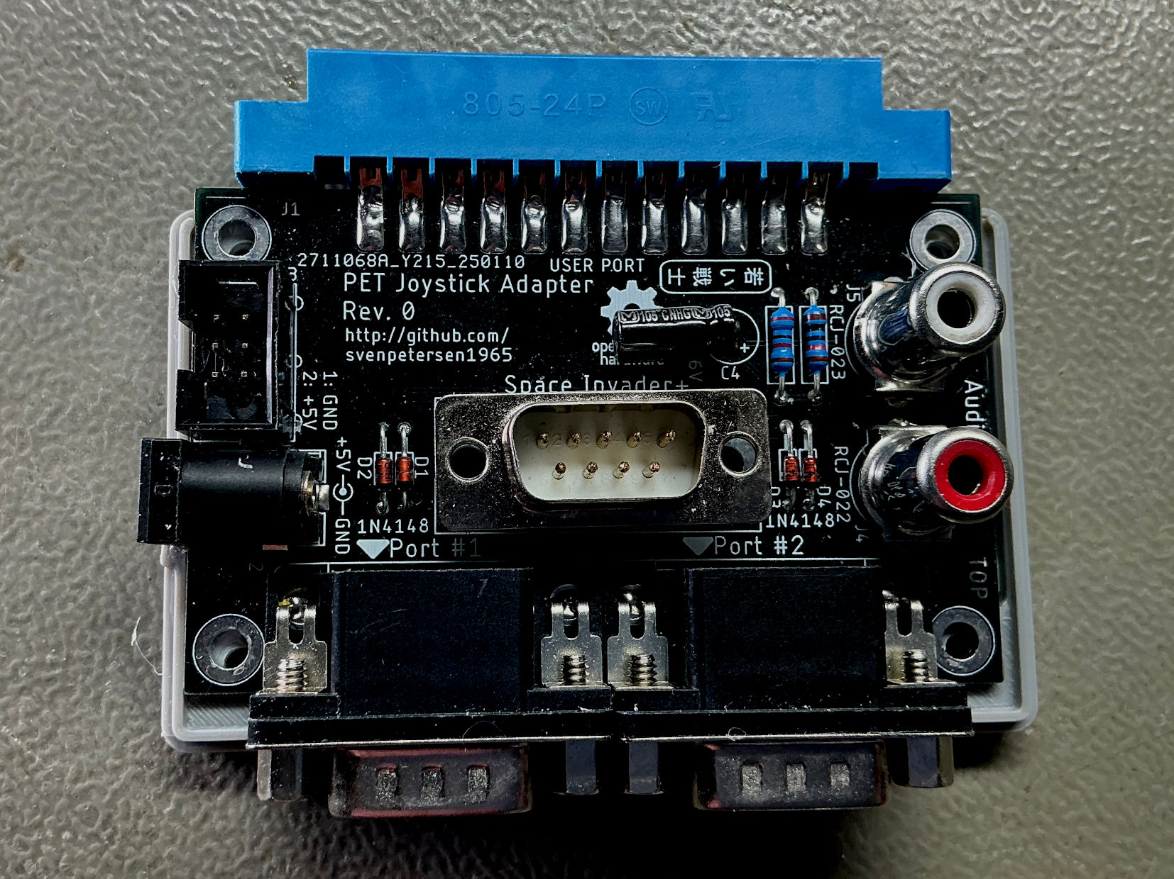
Figure 2: Top side of the PCB

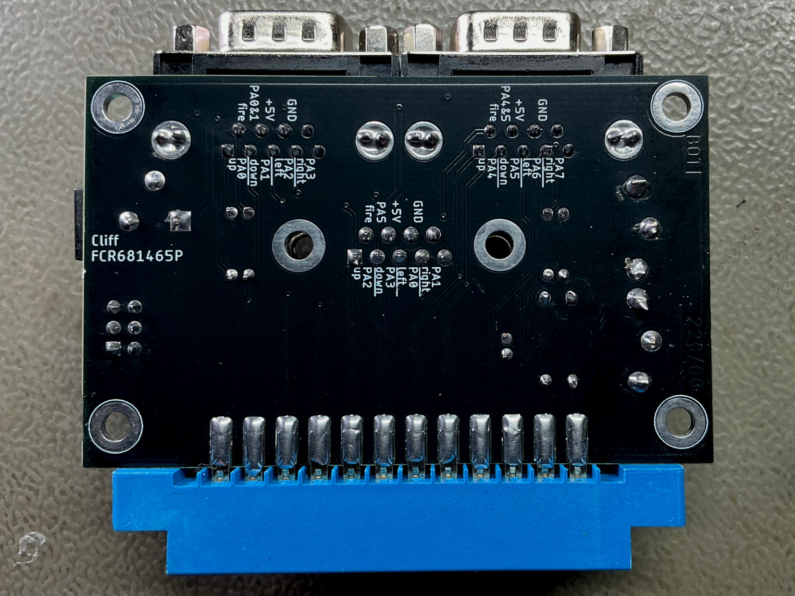
Figure 3: Bottom side of the PCB
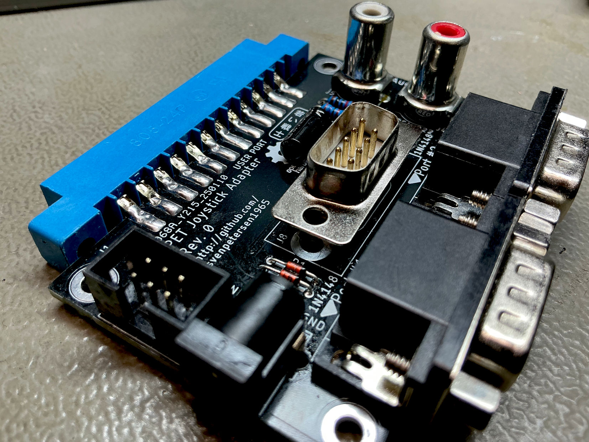
Figure 4: Soldering of the user port connector
The edge connector should be soldered flat on the solder side (Figure 3) and with bent pins on the top side (Figure 4).

Full assembly
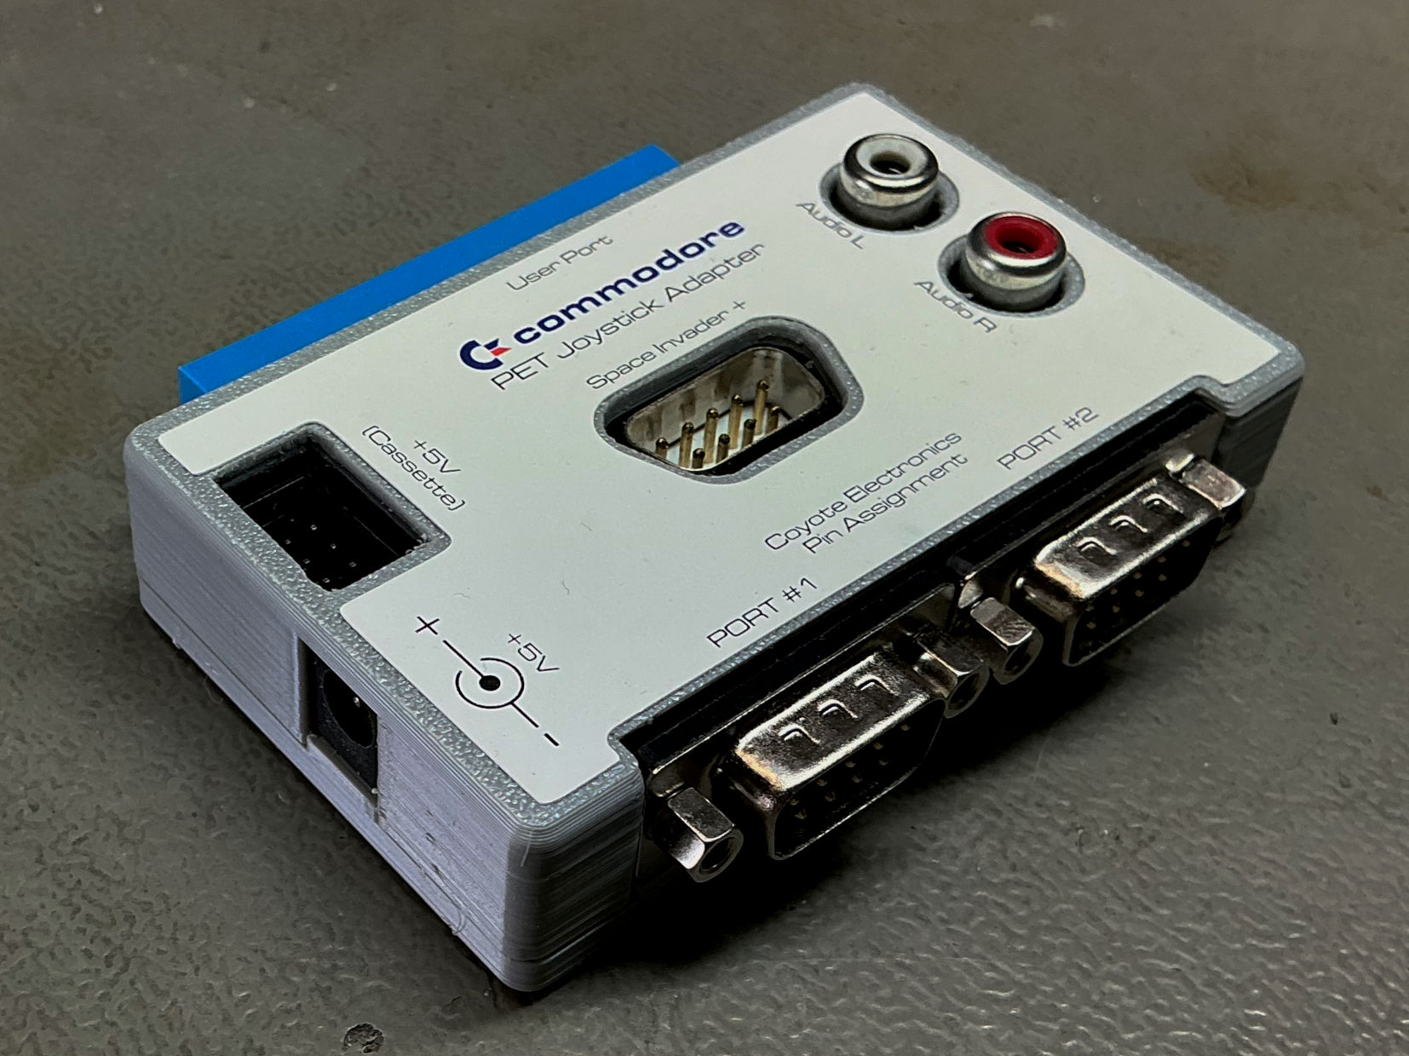
Figure 5: Joystick Adapter with 3D printed case and label

Revision History

Rev. 0
- Working prototype

